Chapter 8: Gravity

8.1 Earth’s gravity pulls objects to the centre of the Earth

Literacy support worksheet answers (pages 144–145)

Gravity

1 Gravity is a force that attracts an object to the centre of the Earth. What is a gravitational field?

The gravitational field is an area around a body in which another body experiences a force of attraction.

Isaac Newton is pictured below on the day he first pondered the idea of gravity.

2 Explain why the apple fell to the ground.

The apple fell to the ground because of gravity, which attracted the apple to the Earth.

3 The apple has a mass of 200 grams (0.2 kg).

On Earth, the apple’s weight would be:

0.2 kg × 9.8 N = 1.96 N.

Using the diagram of the bricks as a guide, calculate what the apple’s weight would be on:

a the Moon:

0.2 kg × 1.6 N = 0.3 N

b Jupiter: _____________________________________

0.2 kg × 23.6 N = 4.7 N

4 Assume Newton’s mass was about 60 kilograms.

On Earth, his weight would be:

60 kg × 9.8N = 588N

What would his weight be on:

a the Moon?

60 kg × 1.6 N = 96 N

b Jupiter?

60 kg × 23.6 N = 1416 N

5 Draw a labelled diagram to explain why a tennis ball and a cricket ball would both fall at the same speed when dropped from the same height. Refer to Figure 8.5 to help you.

Student answers will vary. However, they should note that the mass of the cricket ball is greater than that of the tennis ball, so the cricket ball needs more force to start it moving. This offsets the larger gravitational pull on the cricket ball, so both balls hit the ground at the same time.

WORD DETECTIVE

6 Fill in the gaps

Fill in the gaps using the words listed below.

Gravity is a non-contact force that we experience every day. Isaac Newton was the first person to describe gravity as a force that attracts an object to the centre of the Earth. The Earth is made up of enormous amounts of matter. The greater the amount of matter, the greater the gravitational pull.

The Moon’s gravitational pull is much less than the Earth’s. This is why astronauts are able to jump much higher on the Moon than on the Earth. Weight is a measure of how much gravity pulls on an object. The amount of matter or particles in an object is described as the mass. Even though some objects weigh more and have a greater gravitational pull, if two objects are dropped at the same height and the same time, they will fall to Earth at the same time.

8.2 Gravity keeps planets in orbit around the Sun

Literacy support worksheet answers (pages 146–147)

Gravitational Orbit

1 What theory existed before the scientist Galileo Galilei showed that the Earth orbited the Sun?

Before Galileo showed that the Earth orbited the Sun, it was believed that the Sun orbited the Earth.

2 Using Figure 8.9 on page 147 of the textbook, describe in your own words how the Moon stays in orbit around the Earth.

There is a balance of forces pushing the Moon out and pulling the Moon in, causing it to orbit the Earth.

3 The Moon moves away from the Earth by approximately 3.7 cm per year. How far has it moved:

a since you were born?

Student responses will vary, but for a 12 year old it would be 44.4 cm and for a 13 year old it would be 48.1 cm.

b since either of your parents was born?

Student responses will vary.

c since any of your grandparents were born?

Student responses will vary.

WORD DETECTIVE

4 Secret message

Use words from the student book to work out the secret message below:

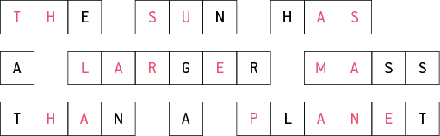

8.3 The Moon’s gravity causes tidal movements

Literacy support worksheet answers (pages 148–149)

Tidal Movement

1 Fill in the boxes to explain the creation of tides (the orange bulge represents the Moon’s gravitational pull and the yellow bulge represents the Sun’s gravitational pull).

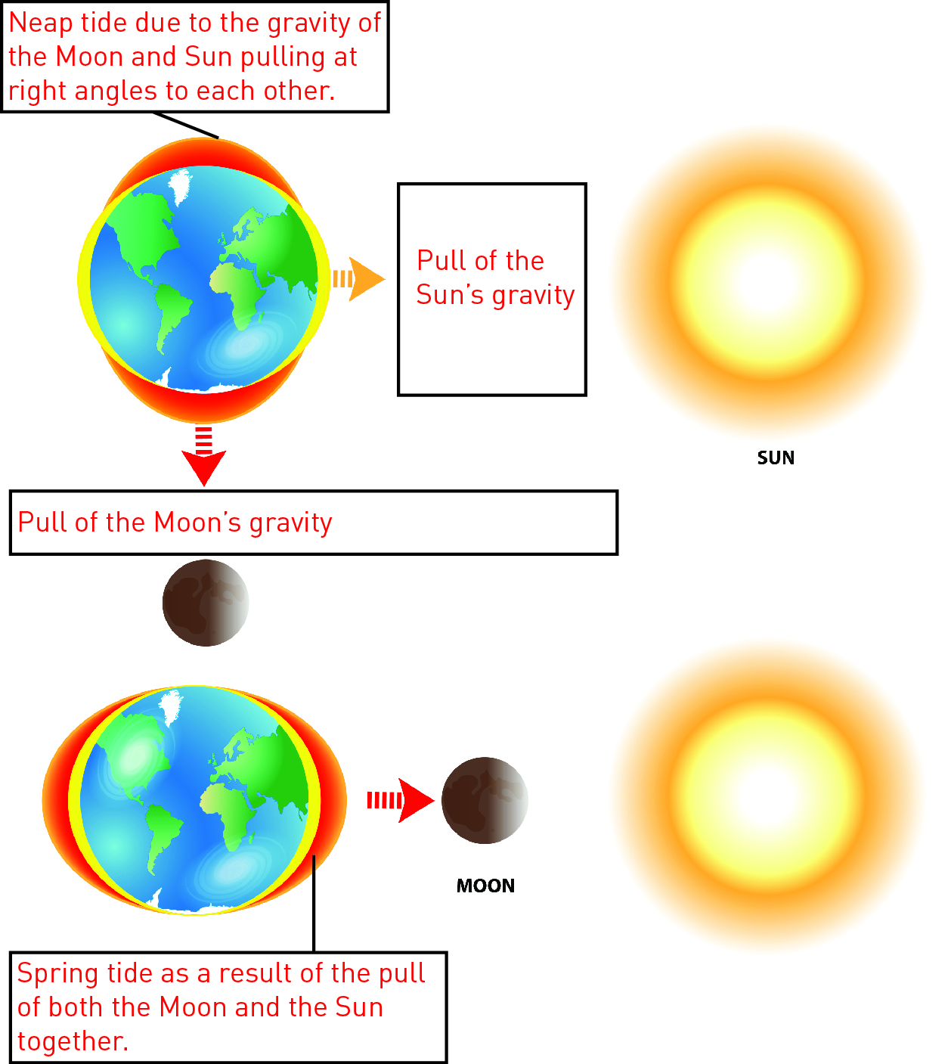

2 The Sun is 400 times further away from the Earth than the Moon, so the Moon has a greater effect on tides even though the Sun is much bigger.

The facts are:

• the mass of the Sun is 27 million times greater than that of the Moon

• the force of the Moon on the tides is 59 million times greater than that of the Sun.

Work out the difference in the tide-causing force using the formula below.



= 0.46 × 100

= 46 %

WORD DETECTIVE

3 Crossword

Use the clues to fill in the crossword.

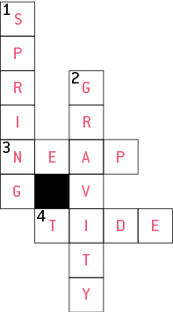

8.4 Science as a human endeavour: Scientists work collaboratively to explore microgravity

Literacy support worksheet answers (pages 150–151)

Microgravity

1 Write two interesting facts about the International Space Station.

• The International Space Station was assembled in space

• It travels at a speed of 27 700 km/h

2 Label the picture with some of the effects of microgravity on an astronaut.

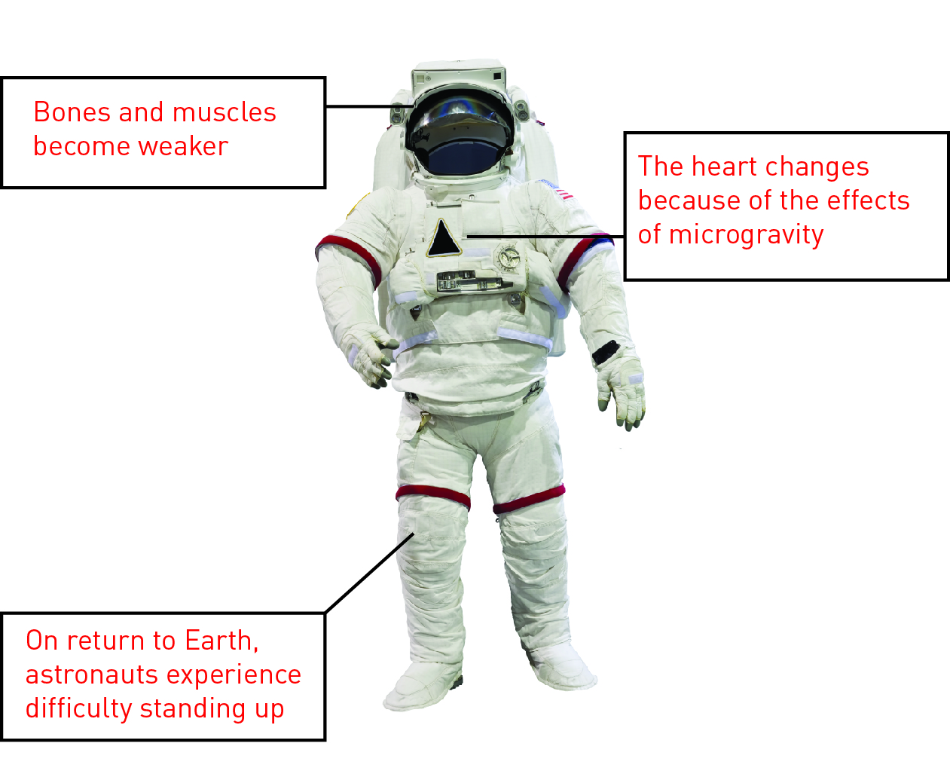

WORD DETECTIVE

3 True or false

Read each statement below and circle T if it is true or F if it is false.

a The ISS stands for the International Space Station

T

b Microgravity is large amounts of gravity

F

c Weight is measured in newtons in space

T

d Astronauts easily break bones after returning to Earth

T

e There is no possibility that we will live on Mars one day

F

f The space station is falling towards the Earth

T